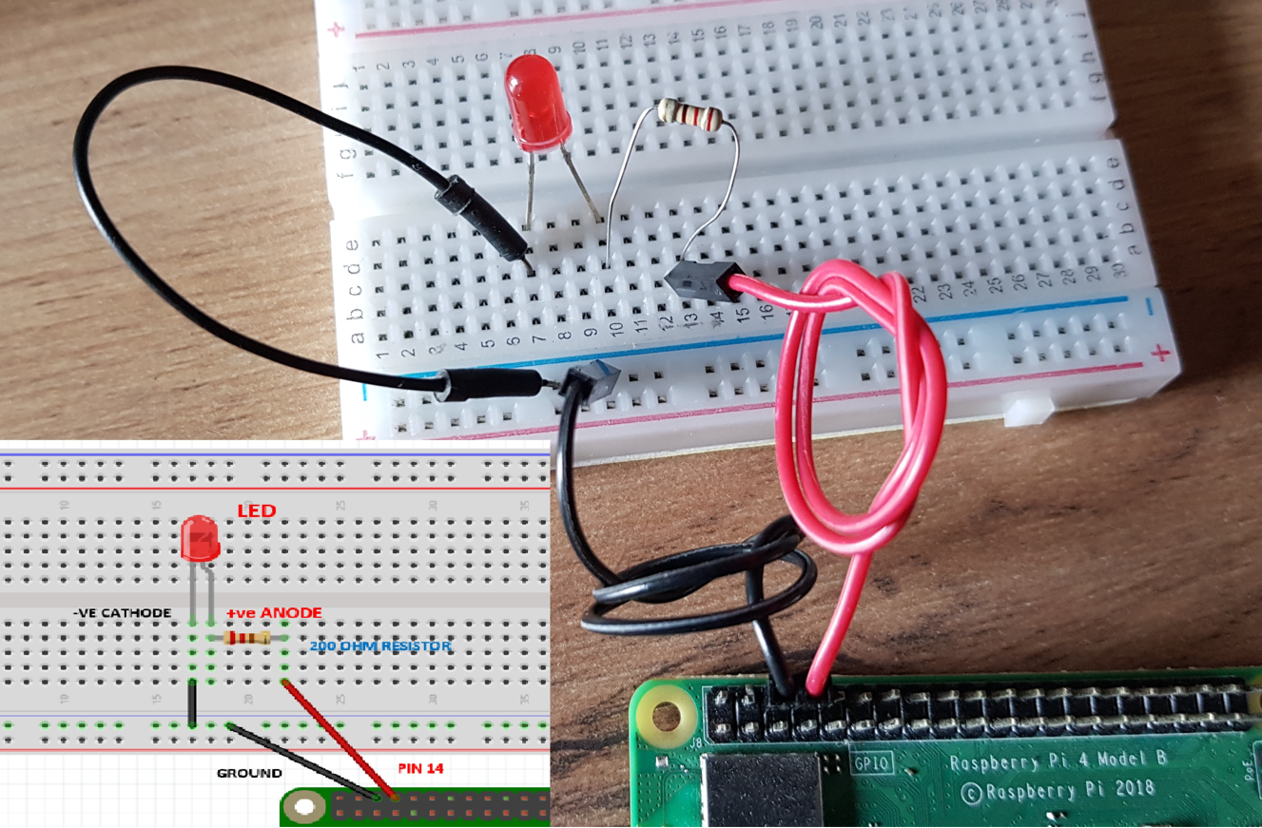

**Inside the Thonny Shell/REPL**

**>>>**

**============================**

**How to control the LED?**

**-make it turn on / off**

**-make it blink?**

**Now wire up the blue LED to PIN 12**

**Repeat the exercise above**